**Bootstrap**

1. **What are the advantages of bootstrap?**

Easy to prevent repetition among multiple projects.

Responsive design that can be used to adapt screen sizes and choose what shows and what doesn’t on any given devices.

Maintaining consistency among projects when using multiple developer teams.

Quick design of prototypes.

1. **What is bootstrap container, and how does it work?**

Containers are the layout element In bootstrap and are requires when using our default grid system.

Containers are used to contain, pad, and center the content within them.

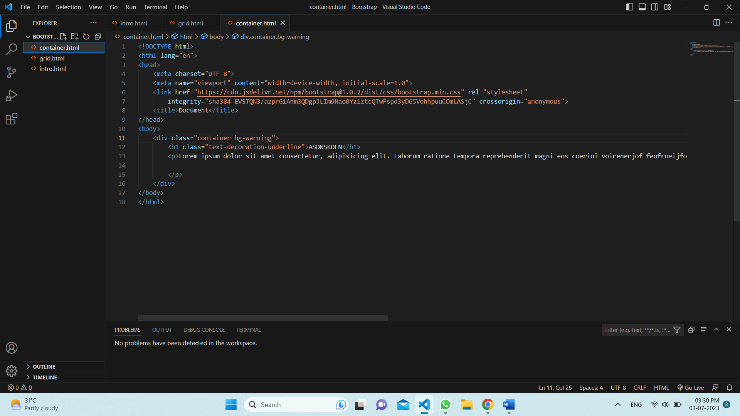

1. **What are the default Bootstrap text setting?**

Bootstrap uses a default font-size of 1rem and its line-height is 1.5 .

1. **What do you know about the Bootstrap grid system?**

There are 12 columns by default in Bootstrap.

If you don’t want to use all 12 columns individually, you can group the columns together to create wider columns.

It is by default responsive.

1. **What is the difference between Bootstrap 4 and Bootstrap 5?**
   * + The form elements in Bootstrap 4 have defaulted to the browser-provided view. However, in Bootstrap 5, the form elements have a custom design that enables them to have a consistent look and feel in all browsers.
     + Bootstrap 4 had limited color options. Bootstrap 5 has included many new color options to its palette.
     + Bootstrap 4 didn’t have an SVG icon library. But bootstrap 5 has taken care of this issue by introducing its own SVG library with 1000+ icons.
2. **What is button group, and what is the class for a basic Button Group?**

A series of button together on a single line or stack them in a vertical column.

Button group is .btn and .btn-group .

1. **How can you use Bootstrap to make thumnails?**

Bootstrap has an easy way to do this with thumbnails.

* + - * + Add an <a> tag with the class of .thumbnail around an image.
        + This adds four pixels of padding and a gray border.
        + On hover, an animated glow outlines the image.

1. **In Bootstrap 4 . what is flexbox?**

In bootstrap 4 flexbox used to control the layout and alignment specification of bootstrap 4components. This box makes it easier to design flexible responsive layout structure without using float or positioning attributes.

1. **How can one create an alert in Bootstrap?**

Alerts are created with the .alert class, and four contextual classes: .alert-success, .alert-info, .alert-warning or .alert-danger .

1. **What is a bootstrap card and how would you crate one?**

A card is a flexible and extensible content container. It includes option for headers and footers, a wide variety of content, contextual background colours, and powerful display options.

A basic card is created with the .card class, and content inside the card has a .card-body class.

The .card-header class adds a heading to the card and the .card-footer class adds a footer to the card.